ODA Extensions and BIRT Part 1
by Scott Rosenbaum
Introduction

A report is made up of three functional components: data access, layout and format, and distribution media. The Eclipse Business Intelligence and Reporting Tools (BIRT) project uses these three basic components as part of its core design. This separation of function allows for better modular report design and helps the report developer create appropriate report designs. Data access is obviously key to any reporting tool and often determines how popular a product will become. BIRT data access is done through components from the Eclipse Data Tools Platform (DTP) project. BIRT has data access drivers for JDBC, XML, Script(code based), and Flat Files. In BIRT 2.2 a Web Services driver will also be added.
Despite all of the out of box data sources, your report developers may have a unique data access requirement. Perhaps they want to access Hibernate objects, maybe EJB's from your web application. In today’s computing environment there are many ways to persist and transfer data. One option is to use the BIRT scripted data source. This option while effective for one off reports is not practical for large groups of reports. It also forces each report developer to get involved in the details of the API for that data source. Wouldn't it be great if you could create a set of GUI based components that will allow report developers to report against your unique data source, using standard drag and drop BIRT functionality?
The ODA was designed to allow this type of add on functionality. Using the ODA extension framework, Eclipse developers can create new types of Data components that will access data from custom data sources, through a user interface that is similar to the out of box BIRT data sources. The report developer just sees a drag and drop interface that will deliver data in the rows and columns format that they can lay out in their report design. The Eclipse developer encapsulates the data source API, isolating the report developer from the implementation details of the data source API.
This is the first of a three part series of articles that highlight the creation of custom ODA components for use in BIRT reports. These articles will walk through a progression from a basic ODA implementation to a fully functional ODA that can be used by any report developer. Part one, will introduce the Eclipse plug-in architecture, the basic ODA interfaces, and the steps required to create a very basic ODA. Part two will focus on the creation of ODA user interface components that allow the ODA developer to provide flexibility and ease of use to the report developer. In part three, we will focus on some of the optional ODA interfaces that can be implemented to provide more advanced functionality.
A little history is important to understand where the ODA comes from. In BIRT 1.0, the ODA components were a part of the BIRT project. As BIRT 1.0 was getting released, the DTP project was starting to address the need for a consistent cross-project approach to data within the Eclipse domain. The BIRT team quickly realized that the proper place for the ODA was within DTP, Eclipse did not need another one off solution to data. In BIRT 2.0 and 2.1 the move to the DTP based ODA has continued as the DTP project has matured. The BIRT 2.2 (Europa) release will be the first release where the ODA fully exists within the DTP. From this point forward, BIRT will access its data through components built in the DTP project.

Requirements to Deploy and Run Examples

- Eclipse BIRT 2.2 Milestone 4 or higher.

Extension Framework
Eclipse has been described as a component framework. The building blocks of the Eclipse framework are called plug-ins. The core Eclipse platform has been built to allow extension through this plug-in framework. Any Eclipse plug-in can allow custom configuration or extension through an extension point. The extension point represents a contract saying, if you follow this basic set of instructions, then I will use you in this way. So when we talk about building a new ODA, we are going to create a new plug-in which it will implement some of the ODA extension points. In Eclipse speak, our new custom plug-in will have an 'extension' (which implements the ODA extension point). The relation between extension points and extensions is shown in the following diagram.

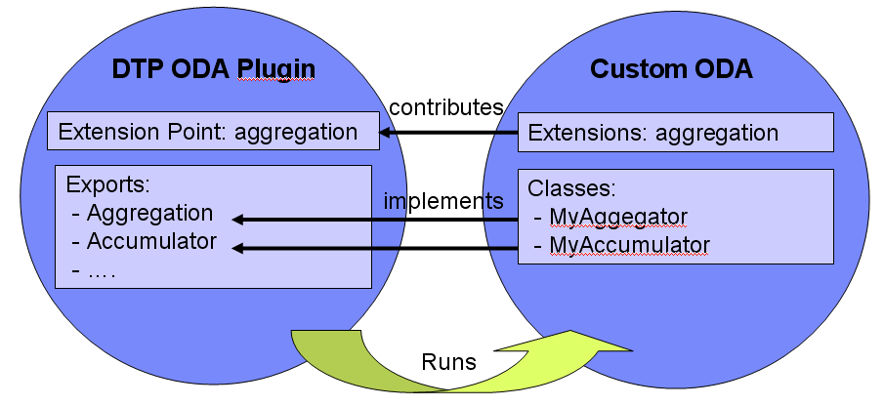
Figure 1 Extension Point

By convention, plug-in projects are differentiated into UI and non-UI projects. Since our ODA will have both visual and non-visual elements, we will create two separate plug-in projects. For BIRT in particular this makes a lot of sense. When building reports, visual design elements are used extensively, so the UI piece is critical. When reports run using the Report Engine, there is no requirement to support all of the design time UI features, so the UI designer for a data source is not needed.
ODA Runtime Plugin
The easiest way to get started building an ODA is to use the Plug-in Development Environment (PDE) plug-in wizards. To do this, select File => New => Project and then select Plug-in Project from the dialog. Click Next and you are taken to a dialog to the New Plug-In Project dialog. So now it is decision time, what to call our new plug-in? In November of 2006, Google released an API to their spread-sheet product. I thought that it would be interesting to create a plug-in that will allow report developers to quickly and easily report on data held within a Google Spread-Sheet. In addition, I said that there would be two projects, a run time project and a design time project. So the best name for this project is google_oda_runtime. The other options should be left as default.
Click Next and you are brought to the "Enter the data required to generate the plug-in." page of the New Plug-In Project. In this page, you can make changes to the name of your project or its project id. Make sure that the “This Plug-in will make contributions to the UI” checkbox is not checked. Also, you do not want to build an RCP application. If you click the next tab, you will be taken to the templates page of the dialog. You want to use the ODA Data Source Runtime Driver Template

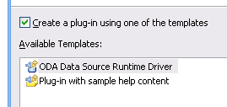
Figure 2 PDE Template

Clicking on the finish button will take you to the Plug-in editor. The plug-in editor is a special multi-tabbed editing window which will allow you to modify the contents of the three files: the plugin.xml, /META-INF/manifest.mf, and build.properties. These three files take care of most of the configuration of a plug-in. There is one additional file, plugin.properties, which is created by the ODA Template that will allow for multi-language support. The values in plugin.properties are referenced in the plug-in editor with entries like %plugin.name.
NOTE: This demo was done using the M4 build of BIRT. There is an issue in the M4 build that should be addressed at this time. The issue is in the META-INF/manifest.mf file. If you open the google_oda_designer/plugin.xml file with the plugin editor, you will see a manifest.mf tab. Opening that tab shows you the contents of the manifest.mf file. You need to add an entry immediately after the Bundle_Activator: entry. Add Bundle-Localization: plugin as shown below.
...
Bundle-Activator: google_oda_runtime.Activator
Bundle-Localization: plugin
Require-Bundle: org.eclipse.core.runtime,
...
In addition, to the configuration files, the ODA Template provides skeleton implementations of the basic interfaces required by the ODA. If you open the source dialog, you will see the following classes.
Each one of these classes implements one of the ODA interfaces. The ODA wizard is implemented to provide a simple working ODA data source.
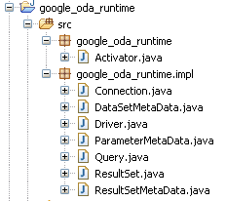
Figure 3 Source Tree for ODA Runtime

These classes have been implemented with a minimal working ODA DataSource and DataSet. So you now have a working ODA, as long as you don't mind seeing the same two columns and four rows of data. I typically like to perform a quick test of my runtime ODA components to make sure that I have all of the basics working. To do this, you need to run the project as an Eclipse Application. You will want to go to the Run menu, select the run option, which takes you to the Run dialog. You should see a launch type named Eclipse Application, double click to create a new runtime launch configuration and accept the default parameters. Click the run button in the lower right corner and a new Eclipse version will be launched.
You are now running a run-time workbench. You will actually create a new workspace, and any plug-in projects that are open in your original session will be loaded into the runtime workbench session. The first thing you will need to do is to create a project in your new workspace. I typically use java projects for reports, just in case I want to create a Java Event handler. Then you need to create a new report. Once you have the new report, switch to the Report Perspective and select the Data Explorer View. Create a new data source and you will see the New Data Source dialog. A dialog similar to figure 4 should be displayed. Select the Google_oda_runtime Data Source and then click Finish.
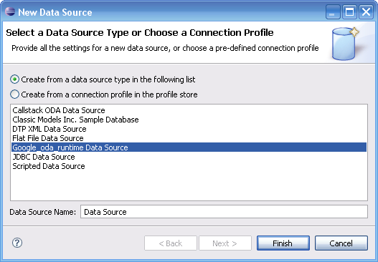
Figure 4 Using the new ODA Runtime

Next add a new data set to your report. In your New Data Set dialog you will see that you can create a new data set that is based on the Data Source from your new ODA. Go ahead and select that data source and click Finish.
You will be taken to the Edit Data Set dialog with which you should be familiar. Report developers should find that the ODA interface works almost identical to the standard out of box BIRT data sources. This means that you can create computed columns with no additional programming. Testing with preview results will show you that the ODA wizard is designed to provide hard coded data out of box. If you drag the DataSet to the report design, a table element will be created which will be bound to your new data set.
ODA Designer UI Plugin
The ODA is designed to work with both a designer and a runtime plug-in. Even if you have minimal design time requirements, you still need to implement a simple ODA Designer. Fortunately, creating a UI component for your new ODA is relatively easy. To build this plugin created a new PDE project. This time we will name the project google_oda_designer. In this case, check the box for UI contributions. You will then get a lot more choices for PDE Templates. Next select the ODA Data Source Designer Template.
The next dialog page is important! In this dialog you will need to establish the references between your designer and your runtime ODA plug-ins. This will require you to enter some values from your runtime project exactly. You will notice that the first item Java Package Name refers to this project. All of the other items are referring to the google_oda_runtime project that you built in the previous step. As long as you have not modified the names, you should be able to use the values as displayed in figure 5.

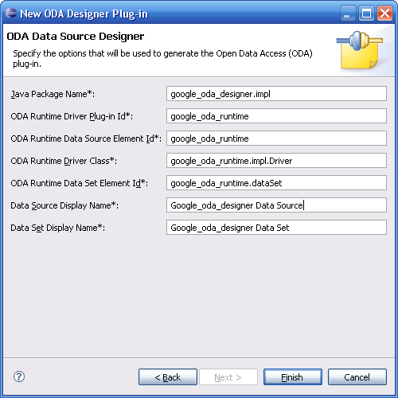
Figure 5 PDE ODA Designer Wizard

When you click on the finish tab, you will see an error in your project. If you go the error, you will see that your new project can not find the: google_oda_runtime.impl.Driver() from the runtime project. Plug-in projects have a built in way of managing project dependencies. In addition, you can control which classes get exposed to other projects. By default, none of the classes in your plug-in project are exposed to other plug-ins. If the designer project is going to work with classes from the runtime project, then the runtime project will need to expose those classes. To do this, go back to the plug-in editor for the ODA runtime project. Select the runtime tab and add both of the packages from your project.
The same issue in the manifest for the runtime project needs to be resolved for the designer project. Opening that tab shows you the contents of the manifest.mf file. You need to add an entry immediately after the Bundle_Activator: entry. Add Bundle-Localization: plugin as shown below.
...
Bundle-Activator: google_oda_designer.Activator
Bundle-Localization: plugin
Require-Bundle: org.eclipse.ui,
...
At this point you should be ready to run the project in the runtime workbench again. Now when you create a DataSource, you are taken to a page that displays Data Source properties. The Template creates two Properties as examples. If you create a DataSet, it will take you to a page that allows you to enter a query. You will need to enter some value, anything will do the data source query is ignored in the skeleton data set created by the Template.

Adding the Link to Google Spreadsheets
So now we need to start adding the functionality to attach to Google spread-sheets. The first thing to look at is the various interfaces that are provided in the ODA extension points. From this tutorial we are only going to focus on the runtime portion of those interfaces. In the next edition, we will examine the designer interfaces. The following illustration shows the ODA interfaces. Those interfaces with a solid black border are required. The four interfaces with no border are optional advanced interfaces, which will be covered, in the third installment of this series.

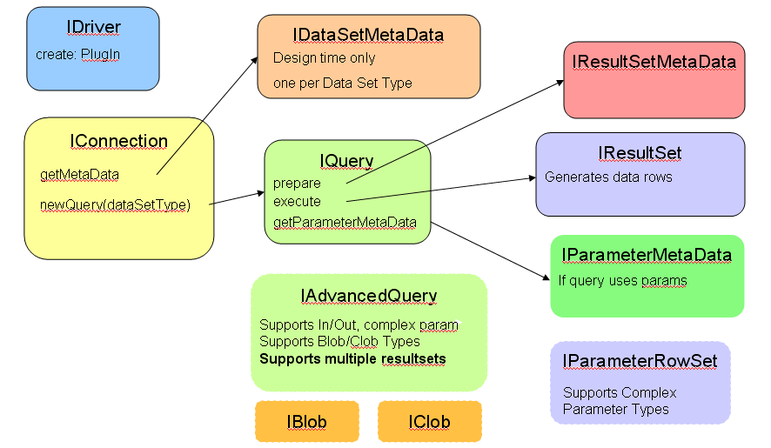
Figure 6 ODA Interface Map
I have not shown the Activator class in this diagram. The Activator, which extends the org.eclipse.core.runtime.Plugin allows your component to react to the appropriate life cycle events that are called by the Eclipse platform. The ODA Activator will use its PLUGIN_ID value to figure out the appropriate IDriver class to start up. The IDriver class is responsible for setting up logging (based on a LogConfiguration configured in the plugin.xml) and for the instantiation of the appropriate IConnection interface. One driver may support multiple versions of the IConnection interface.
Each data source will have at least one type of IConnection interface implemented. The IConnection will have a IDataSetMetaData which describes the type of DataSet (result set) and an IQuery interface where you specify the query sent to the data source. The IQuery in turn will implement two interfaces: IResultSetMetaData, which describes the columns in a query and IResultSet, which processes the data as it is returned from the data source.
The best way to understand the various interfaces is to go ahead and start implementing the interfaces. If you have never used Google docs, I recommend that you go to docs.google.com and log in using user:info@innoventsolutions.com password: innovent2007. You can take a look at the spread-sheets that I have there and add your own if you would like. Now we need to get access to the Google SpreadSheets from our plug-in projects.
To use the Google APIs, you will need to pick up the Google client code available at Google Code. To use the Google API, you need to make the gdata libraries available to your plug-in projects. There are two options to do this. The quickest is to just add the libraries to the Runtime project. The downside of this approach is that both the designer and the runtime would need the libraries. A better approach is to create a new plug-in project. In this project you don't even need an Activator class, but you do want to make sure that on the runtime tab you export all of the Google packages. On that same tab, you also need to add the GData files to the class path (important don't miss this step).
Once I have my gdata project created, I can add that project to my plug-in dependencies using the plugin.xml manifest editor of the runtime project. The Google SpreadSheet API is relatively simple to use. The following code listing shows how to log in to my spreadsheets, and then iterate through each of the spread-sheets displaying the content of each worksheet. It's not particularly pretty output, but it shows the code that I need to implement in my ODA.

public static void main(String[] args) throws IOException, ServiceException
{
// Authenticate to Google Spreadsheets
com.google.gdata.client.spreadsheet.SpreadsheetService service = new SpreadsheetService("innovent - birtDataSet - 1");
service.setUserCredentials("info@innoventsolutions.com", "innovent2007");
// get all SpreadSheets for the user
FeedURLFactory factory = FeedURLFactory.getDefault();
SpreadsheetFeed spreadsheet_feed;
spreadsheet_feed = service.getFeed(factory.getSpreadsheetsFeedUrl(), SpreadsheetFeed.class);
// Iterate over each SpreadSheet, get the worksheet feed.
for (SpreadsheetEntry spreadsheet : spreadsheet_feed.getEntries()) {
System.out.println(spreadsheet.getTitle().getPlainText());
WorksheetFeed worksheet_feed = service.getFeed(spreadsheet.getWorksheetFeedUrl(), WorksheetFeed.class);
for (WorksheetEntry worksheet : worksheet_feed.getEntries()) {
System.out.println(" -" + worksheet.getTitle().getPlainText() + " " + worksheet.getListFeedUrl());
showWorkSheet(service, worksheet.getListFeedUrl());
System.out.println("\n-----------------------------------------------------------\n\n");
}
}
}
public static void showWorkSheet(SpreadsheetService service, URL feedUrl) throws IOException, ServiceException {
ListQuery query = new ListQuery(feedUrl);
// Use the ListFeed to work with the entire worksheet contents
ListFeed feed = service.query(query, ListFeed.class);
for (ListEntry listEntry : feed.getEntries()) {
for (String tag : listEntry.getCustomElements().getTags()) {
String rowName = listEntry.getTitle().getPlainText();
String colName = tag;
String cellValue =listEntry.getCustomElements().getValue(tag);
System.out.println("row(" + rowName + ") col( " + colName + ") " + cellValue );
}
}
}

The first place that I need to start adding code is to the Connection. Looking at the Connection code, you will see that there is an open method, that is passed a Properties object. The question is, where do the properties for this object come from. We now have to go back to the plug-in manifest editor and start to investigate how the Wizard configured our plug-in. Opening the Extensions tab, you will see that the org.eclipse.datatools.connectivity.oda.dataSource has been implemented. Under this extension point, we have a dataSource and a dataSet. The dataSource corresponds to the connection, the dataSet to the query and the resultSets. Examining the dataSource extension and you will see how the plug-in references our Driver class. In addition, you will see that two properties have been configured here. Change the names of these properties to username and password, we will use these values to specify how to log into Google SpreadSheets.
Now that we know where our properties are coming from, we can implement our open code. NOTE: the code samples that I provide here and in the samples have minimal error handling.

public void open(Properties connProperties) throws OdaException {
// service and isOpen are class variables
service = new SpreadsheetService("innovent - google ODA - 1");
String user = connProperties.getProperty("username");
String pass = connProperties.getProperty("password");
try {
service.setUserCredentials(user, pass);
} catch (AuthenticationException e) {
throw new OdaException(e);
}
m_isOpen = true;
}
So now we can log into to Google SpreadSheets. Now we need to setup our Connection so that it can create queries. Eventually we will add some caching to this method, so that our query object is not re-created on every call, but for this first pass through the data, all we need to do is Instantiate our Query class, passing it a handle to the SpreadsheetService.

public IQuery newQuery(String dataSetType) throws OdaException {
//TODO: add query caching
return new Query(service);
}

You can see that I have changed the Query object constructor to take the SpreadsheetService as a parameter. The query object will have its prepare method called with the queryText passed as a string. Eventually, we will want to modify the designer so that report developers can select the WorkSheets feeds from a drop-down, but for for now we will just enter the WorkSheet feed URL that we can get from our sample app. Given that we have appropriate WorkSheet feeds, we can just create our ListFeed object in the Query and pass that to the ResultSetMetaData or ResultSet objects as needed. The prepare method of the Query object gets the query text.

public void prepare(String queryText) throws OdaException
{
try {
URL targetURL = new URL(queryText);
ListQuery query = new ListQuery(targetURL);
listFeed = service.query(query, ListFeed.class);
} catch (Exception e){
throw new OdaException(e);
}
}
Note: as with the Connection object there are caching issues that need to be considered in your Query class implementations. These issues will be addressed in the next installment of this series. Now that we have a ListFeed to our spread-sheet we need to implement the IResultSetMetaData and IResultSet interfaces. The IResultSetMetaData interface will provide information about the columns that we are going to return. For this exercise, we are going to treat all incoming data as strings (this will get fixed in the third installment), so all we need to do is get the columnNames. First, we will modify the constructor of our ResultSetMetaData to take the ListFeed entries as an input parameter.

private List<String> colHeaders = new ArrayList<String>();
public ResultSetMetaData(List<ListEntry> entries){
for (ListEntry listEntry : entries) {
for (String tag : listEntry.getCustomElements().getTags()) {
colHeaders.add(tag);
}
break; // only need the first row of data
}
}

This piece of code grabs the first line of data from the spread-sheet, which will have the names of the column headers. The following four methods need to be modified to return the information that we have captured in the colHeaders values.

public int getColumnCount() throws OdaException {
return colHeaders.size();
}
public String getColumnName(int index) throws OdaException {
return colHeaders.get(index - 1 );
}
public String getColumnLabel(int index) throws OdaException {
return getColumnName(index); // default
}
public int getColumnType(int index) throws OdaException {
return java.sql.Types.CHAR;
}

Now the only thing left to do is to implement the ResultSet which will actually process the data. I normally like to see if things are working before moving along too much further. We should be able to run the project as it is now. The only issue that we have to clean up is that we need to fix the compiler error in the ResultSet. You will notice that in the getMetaData method is building a ResultSetMetaData object, when we changed this object we broke this code. For now just change the method to return new ResultSetMetaData(null);

You can now run the projects using the runtime workbench. You will need to change the parameters in the DataSource object to use the appropriate usename and password values. Also, you will need to change the Query text to be a valid Google spread-sheets feed URL. You can use the test program to get a valid Worksheet feed url. When you do this, you should see that your DataSet now has the columns from the work-sheet. The preview tab will still show the hard-coded values but it will have values for all of the columns in the work-sheet.

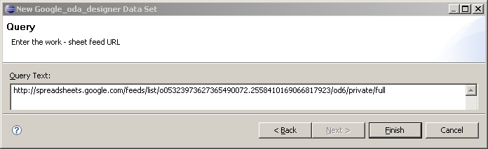 Figure 7 New ODA Query
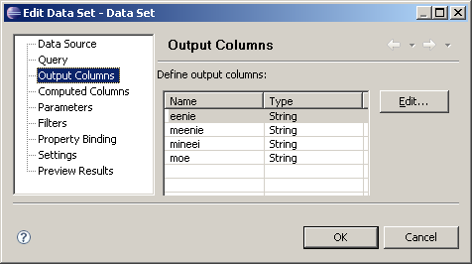
Figure 7 New ODA Output Columns

So the last step for this exercise is to implement the ResultSet interface. First, lets change the constructor for the ResultSet so that it takes the ListFeed as an input parameter.

// class variables
private int m_maxRows;
private int m_currentRowId;
private List<ListEntry> rows = new ArrayList<ListEntry>();
private Iterator<ListEntry> rowIter;
private ListEntry curRow;
private IResultSetMetaData resultSetMetaData;
// new constructor
public GoogleResultSet(ListFeed inFeed ){
rows = inFeed.getEntries();
rowIter = rows.listIterator();
resultSetMetaData = new GoogleResultSetMetaData(rows);
}
Next we create an iterator that will walk through the rows in the ListFeed and store a copy of the resultSetMetaData. Then we modify the next method for the ResultSet so that it will walk through the data returned by the ListFeed. The next method returns true if there is more data to process and returns false if there is no more data. In addition, we increment a pointer that identifies the row that we are working with.
public boolean next() throws OdaException
{
// If the query has a row limit, obey the row limit
int maxRows = getMaxRows();
if (maxRows > 0 && m_currentRowId > maxRows){
return false;
}
if (rowIter.hasNext()) {
// For the Google SpreadSheets, we are always using
// first row as header info. That is why you call next
// on the first row which means first row is actually second row of the sheet.
m_currentRowId++;
curRow = rowIter.next();
return true;
}
// no data, return false to signify end of the results
m_currentRowId = 0;
return false;
}

The only remaining task is to implement the methods that get data from the row based on either the columnName or the column index. We only have to do this for the String interfaces, since that is all that we are implementing for now with the Google ODA.

public String getString(int index) throws OdaException
{
// Google allows access to the Data value through CustomElements.getValue(columnName)
// Google does not support index based lookup, so use the ResultSetMetaData
String colName = this.resultSetMetaData.getColumnName(index);
return curRow.getCustomElements().getValue(colName);
}
public String getString(String columnName) throws OdaException
{
return curRow.getCustomElements().getValue(columnName);
}
Summary
You should now have a custom ODA that will read data from the Google Spread-Sheets. In the next issue we will look at the following topics:

- Logging - implement appropriate logging strategies
- Optimization - implement appropriate caching strategies
- Designer UI - implement a better UI for the report developer to select the work-sheet
- DataTypes - use column data types

Resources

- Docs.google.com
- www.eclipse.org/birt

